**Lab # 6**

**TASK 1:**

Define a class **Addition** which has **static** two member variables **num1, num2** and one **static** member function **add.** This program return the resultant sum of two numbers.

Sample out:

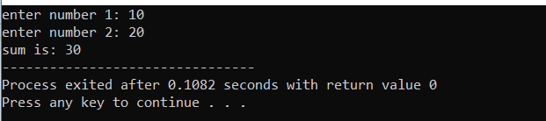

**Task 2:**

Define a class **CalculateArea** having three data members length, breadth, area and another **friend** class **Area** that print the calculated area. The data members should be initialized through constructor.

Sample output:

